Ceiling Speaker T-575

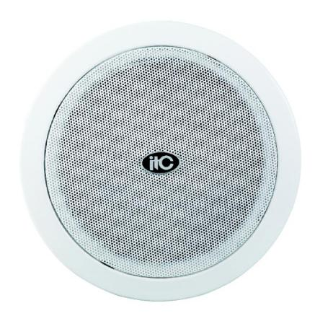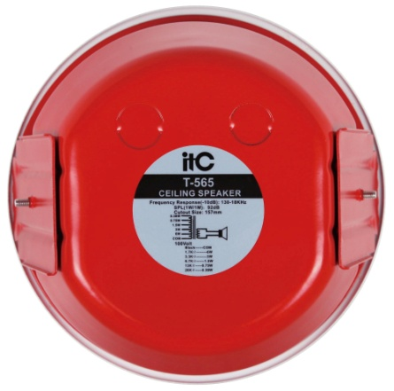

Features:
Multi-power selection flame-retardant fire-resistant ceiling speaker. Built-in temperature cut-out, T-575 uses 2 frequency division coaxial design, clear and full sound, ideal for your fire sound. Applicable to: shopping malls, supermarkets, hotels, etc.

Model | T-575
Rated Power (100V) | 0.38W, 0.75W, 1.5W, 3W, 6W
Rated Power (70V) | 0.19W, 0.38W, 0.75W, 1.5W, 3W
Maximum Sensitivity | 100dB
Sensitivity | 92dB
Impedance | Com / 26KΩ/ 13KΩ/ 6.7KΩ/
 | 3.3KΩ/ 1.7KΩ
Frequency Response (-10dB) | 120-18KHz
Speaker Unit | 6"×1 1.5"×1
Installation Opening Size | φ207mm
Size | 230×126mm
Weight | 1.6Kg

